Hasil Running – Latihan Micronaut JPA Hibernate

Hasil Running Junit

dedi@dedi-HP-Notebook:~/Tugas/praxis-academy/novice/04-05/latihan/latihanMicronautJPAHibernate/complete$ gradlew test

BUILD SUCCESSFUL in 1s

4 actionable tasks: 4 up-to-date

dedi@dedi-HP-Notebook:~/Tugas/praxis-academy/novice/04-05/latihan/latihanMicronautJPAHibernate/complete$

Hasil test dari file index testable

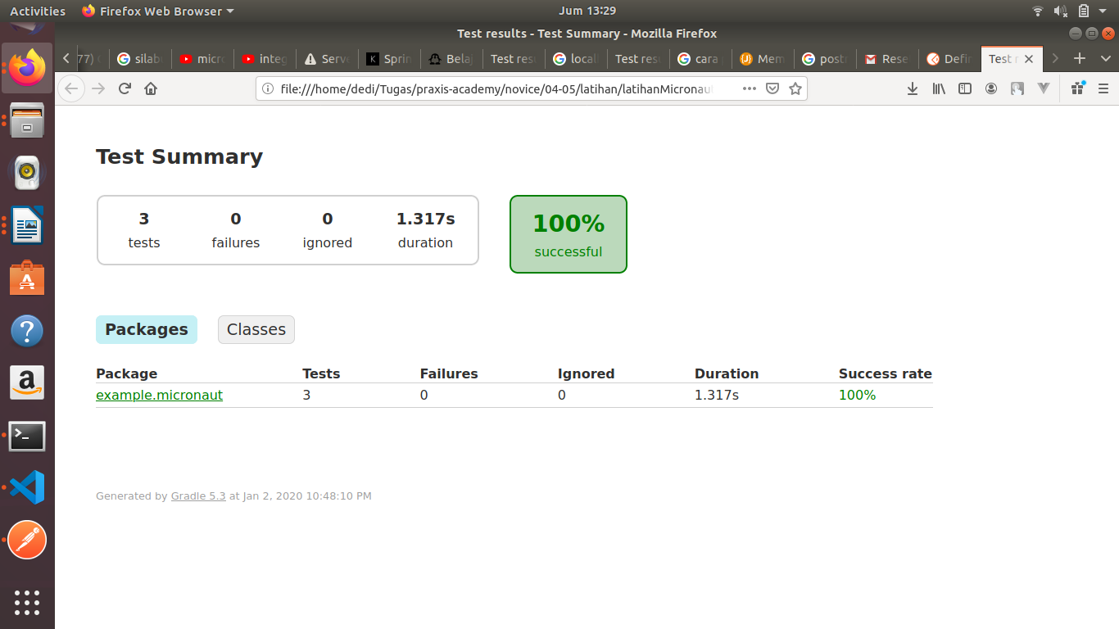

Hasil running

dedi@dedi-HP-Notebook:~/Tugas/praxis-academy/novice/04-05/latihan/latihanMicronautJPAHibernate/complete$ **gradlew run**

> Task :run

13:31:53.417 [main] INFO com.zaxxer.hikari.HikariDataSource - HikariPool-1 - Starting...

13:31:53.491 [main] INFO com.zaxxer.hikari.HikariDataSource - HikariPool-1 - Start completed.

13:31:53.503 [main] INFO org.hibernate.Version - HHH000412: Hibernate Core {5.4.6.Final}

13:31:53.661 [main] INFO o.h.annotations.common.Version - HCANN000001: Hibernate Commons Annotations {5.1.0.Final}

13:31:53.733 [main] INFO org.hibernate.dialect.Dialect - HHH000400: Using dialect: org.hibernate.dialect.H2Dialect

Hibernate: create table book (id bigint not null, isbn varchar(255) not

null, name varchar(255) not null, genre_id bigint, primary key (id))

Hibernate: create table genre (id bigint not null, name varchar(255) no

t null, primary key (id))

Hibernate: alter table genre drop constraint if exists UK_ctffrbu4484ft8dlsa5vmqdka

Hibernate: alter table genre add constraint UK_ctffrbu4484ft8dlsa5vmqdka unique (name)

Hibernate: create sequence hibernate_sequence start with 1 increment by 1

Hibernate: alter table book add constraint FKm1t3yvw5i7olwdf32cwuul7ta foreign key (genre_id) references genre

13:31:54.256 [main] INFO o.h.e.t.j.p.i.JtaPlatformInitiator - HHH000490: Using JtaPlatform implementation: [org.hibernate.engine.transaction.jta.platform.internal.NoJtaPlatform]

13:31:54.529 [main] INFO io.micronaut.runtime.Micronaut - Startup comp

leted in 4652ms. **Server Running: http://localhost:8089**

<=========----> 75% EXECUTING [9s]

<=========----> 75% EXECUTING [21s]

Hasil testing menggunakan Postman

Kondisi awal : tidak ada data

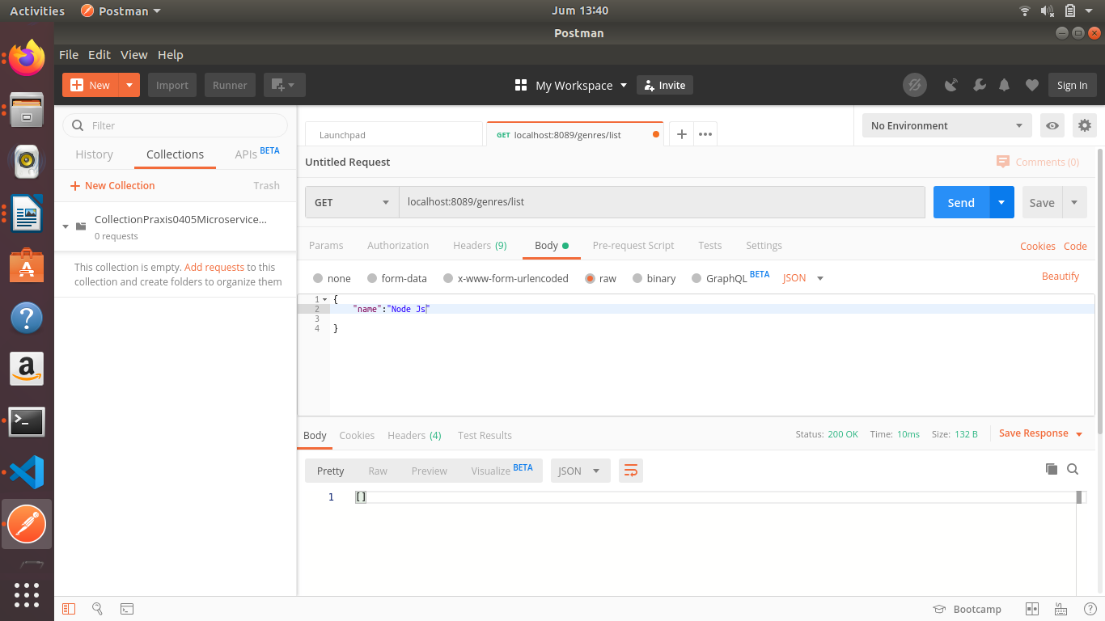

Add data : “DevOps”

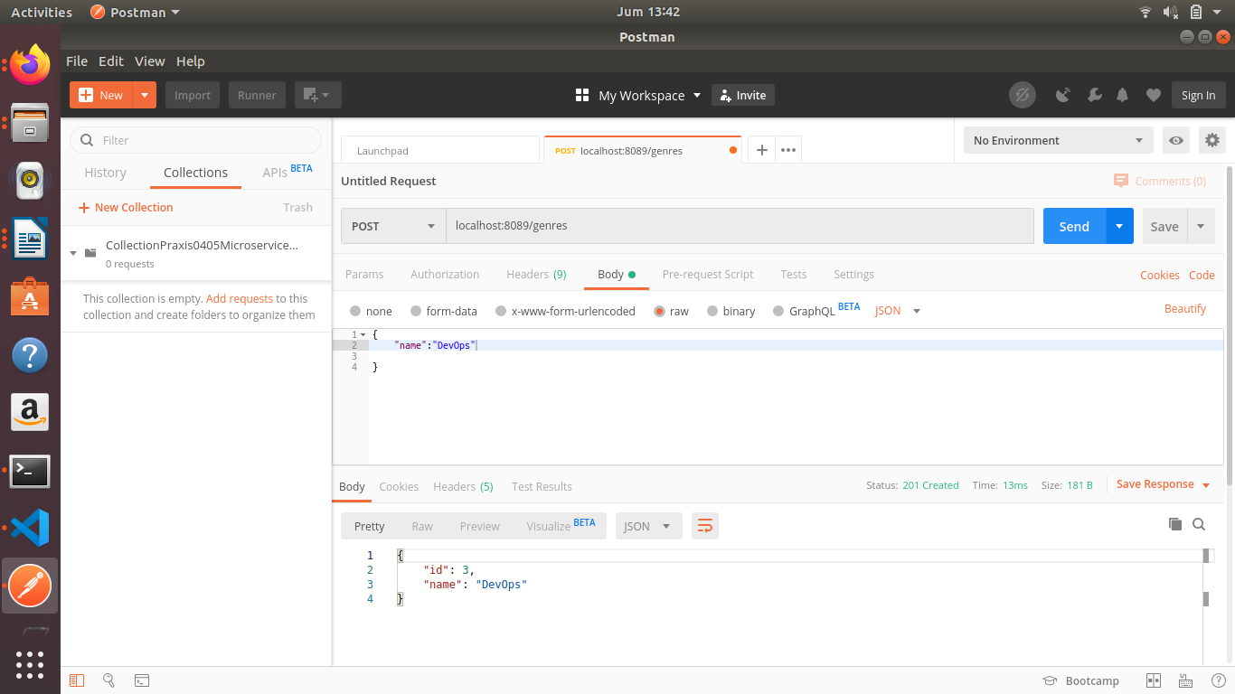

List data : “DevOps”

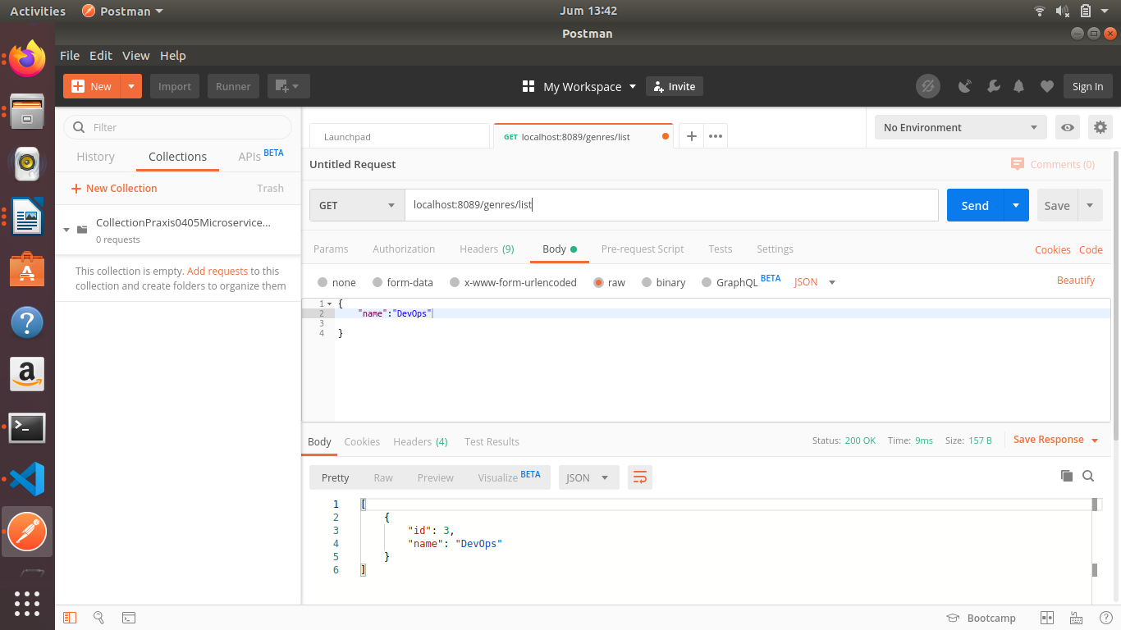

Add data : “MicroService”

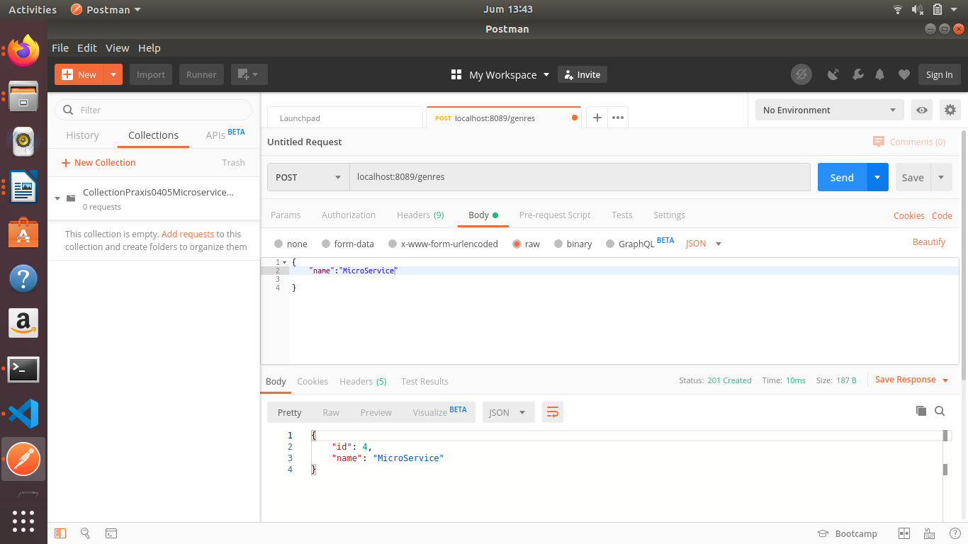

List data : DevOps dan MicroService

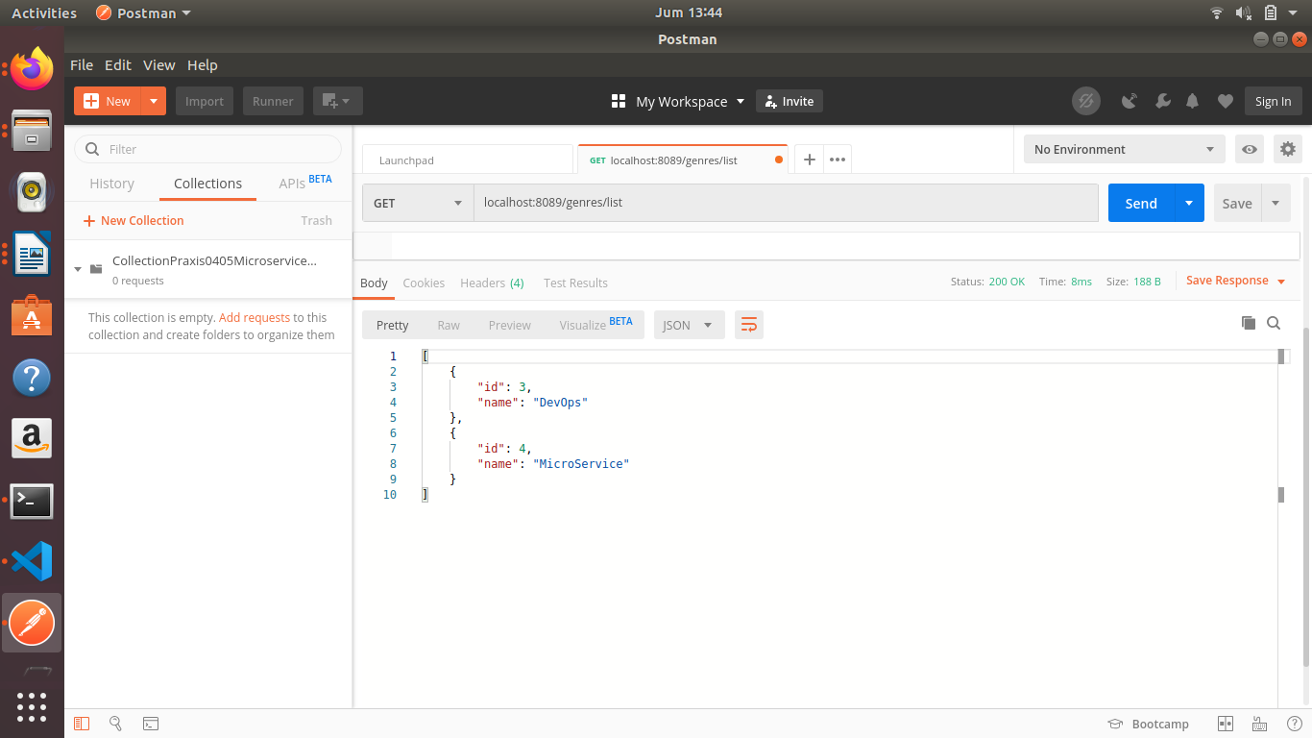

Menampilkan 1 id saja, yaitu DevOps

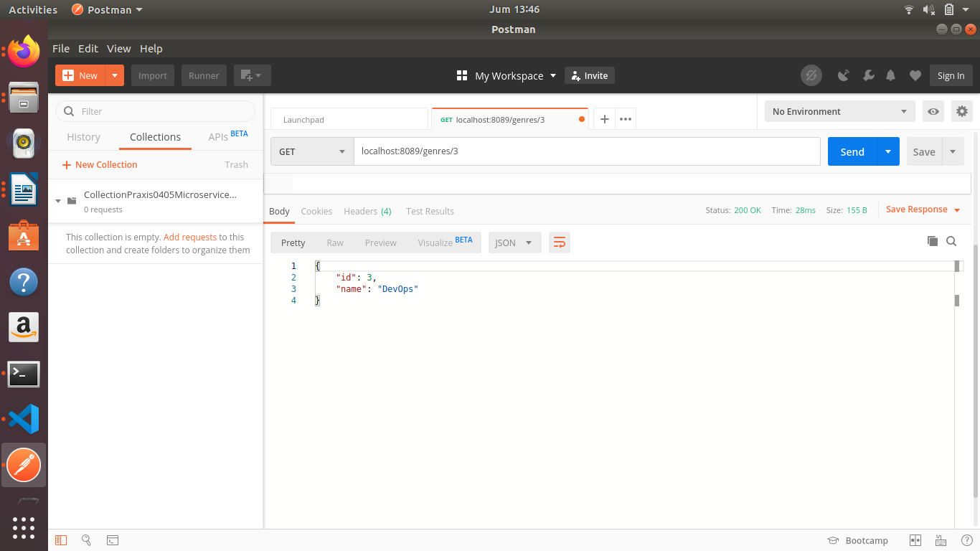

Mengupdate data MicroService menjadi Micro-Service

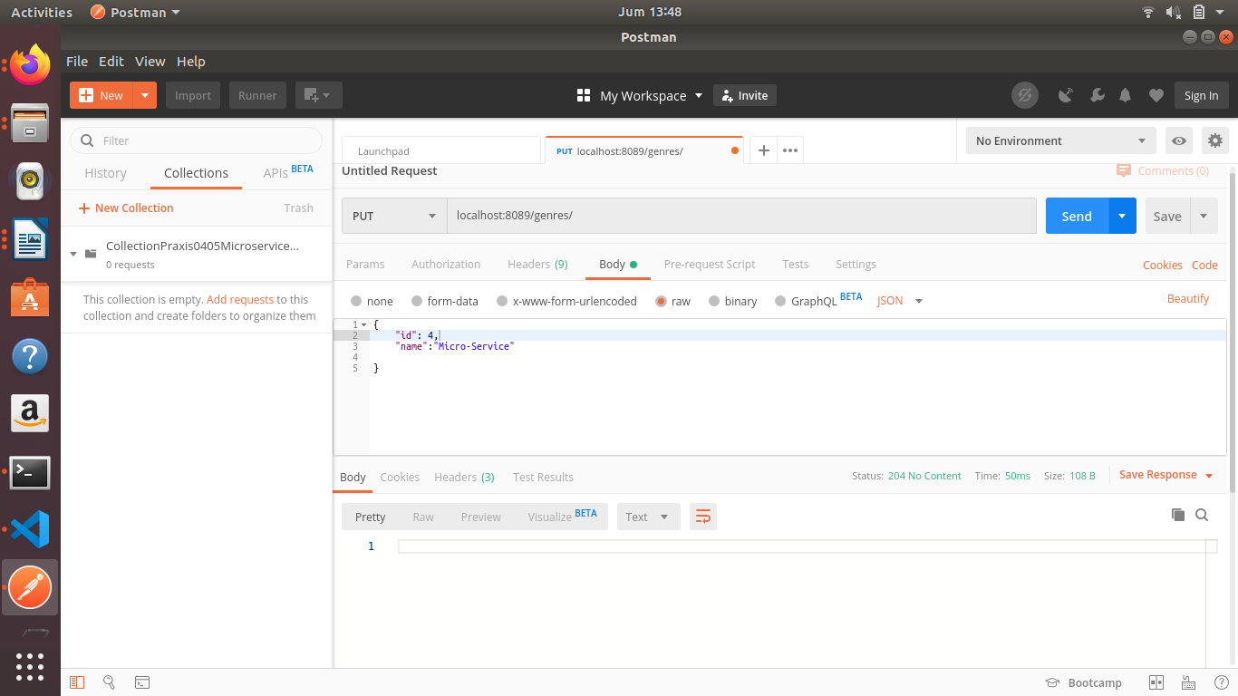

Menampilkan hasil update MicroService menjadi Micro-Service

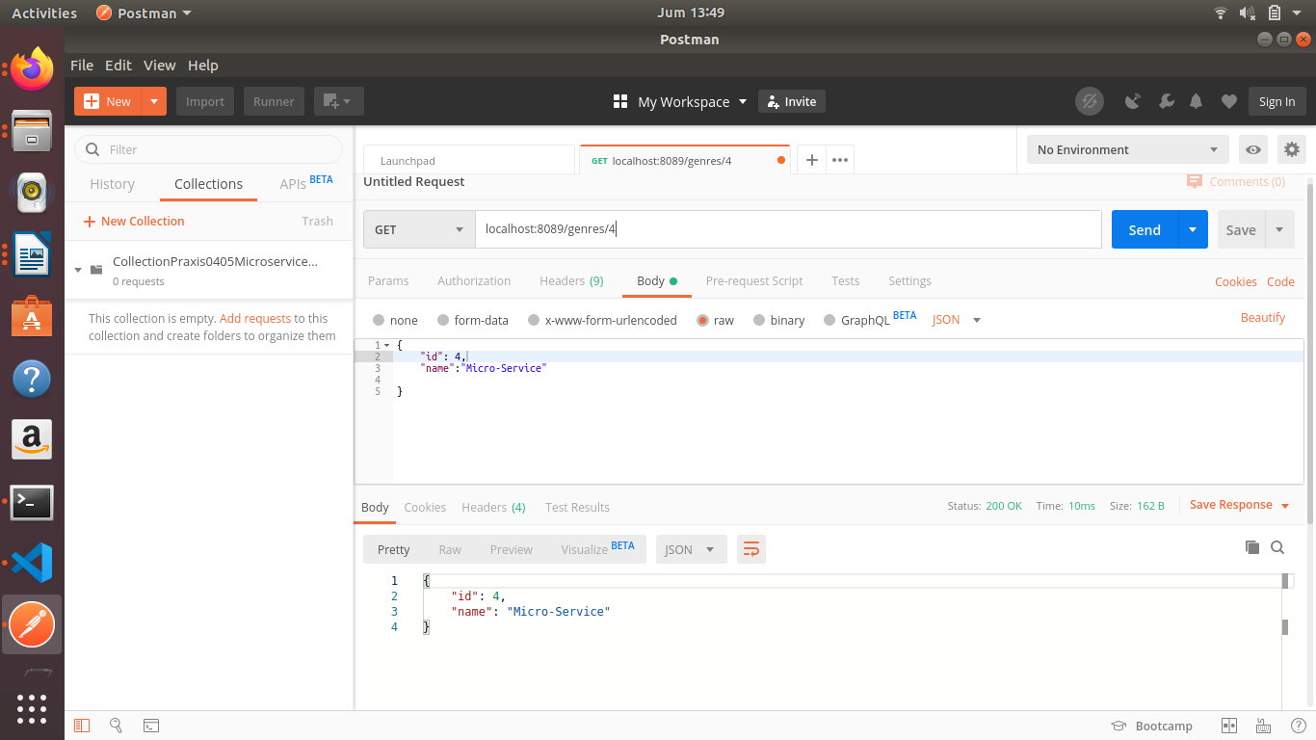

Salah format kirim

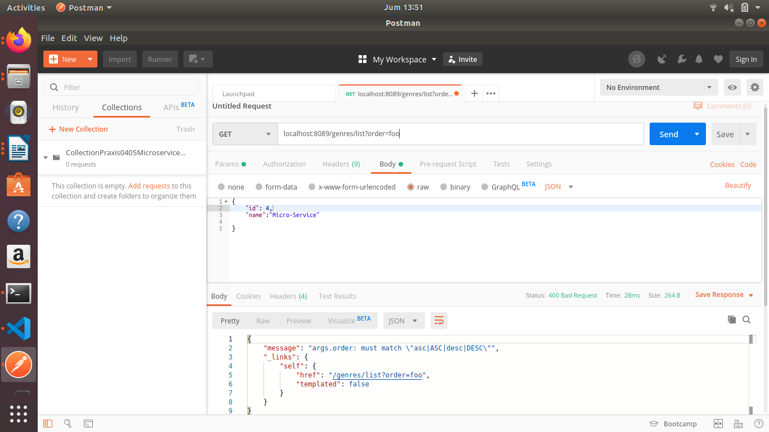

Tidak ada di database

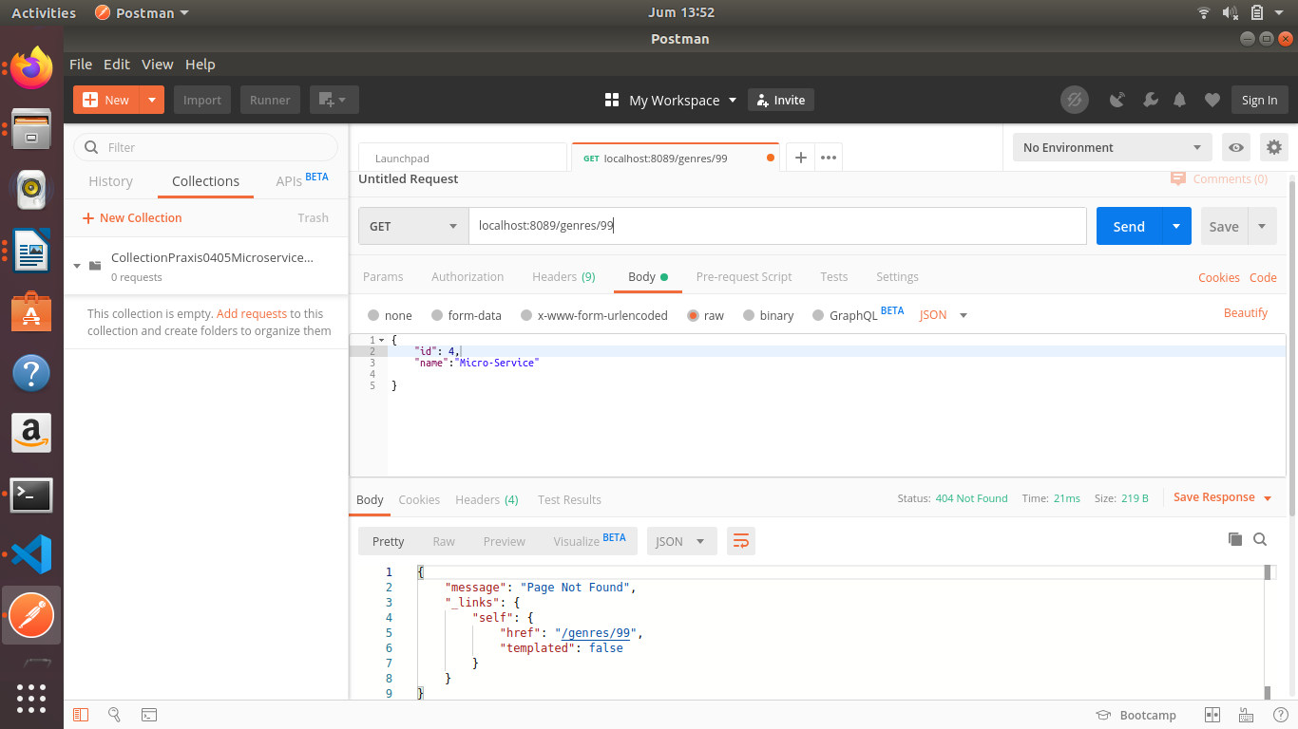

Menampilkan 1 buah record maximal

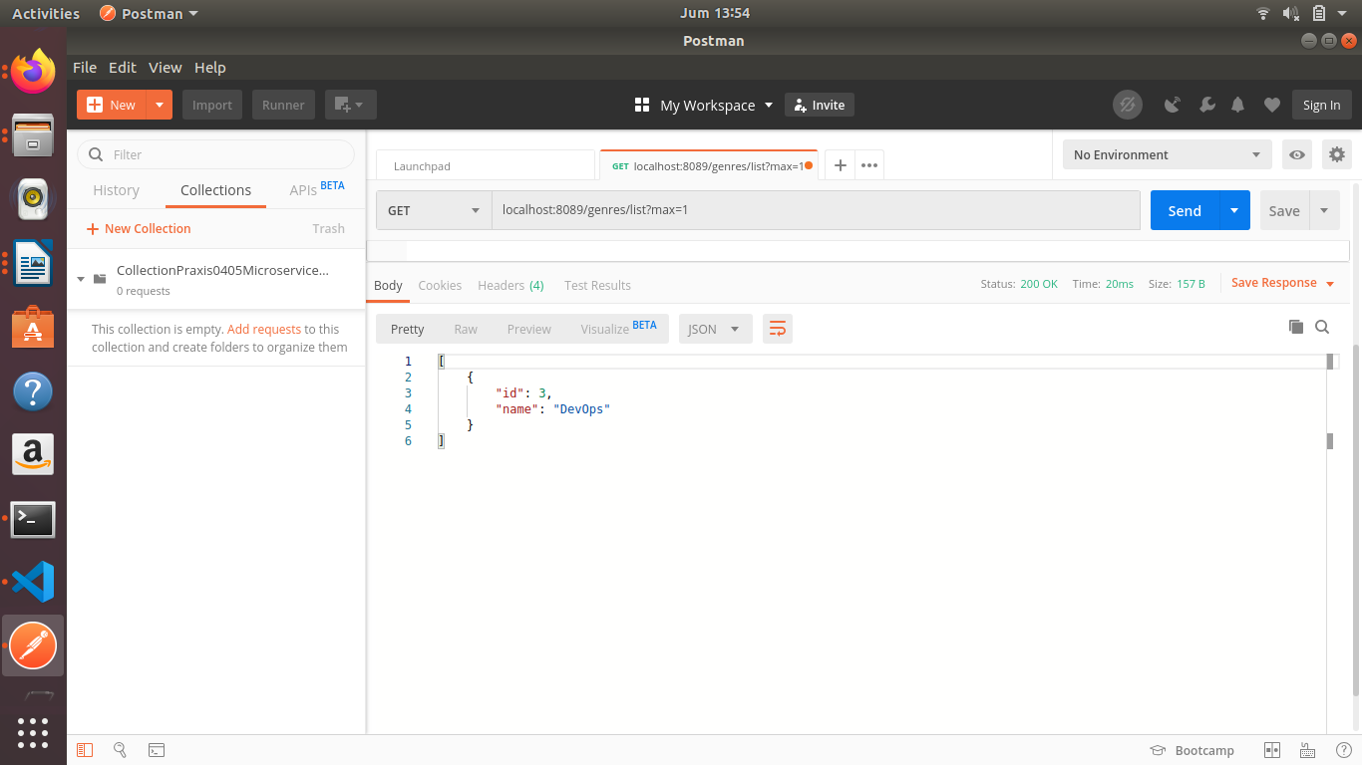

Menampilkan 2 buah record maximal

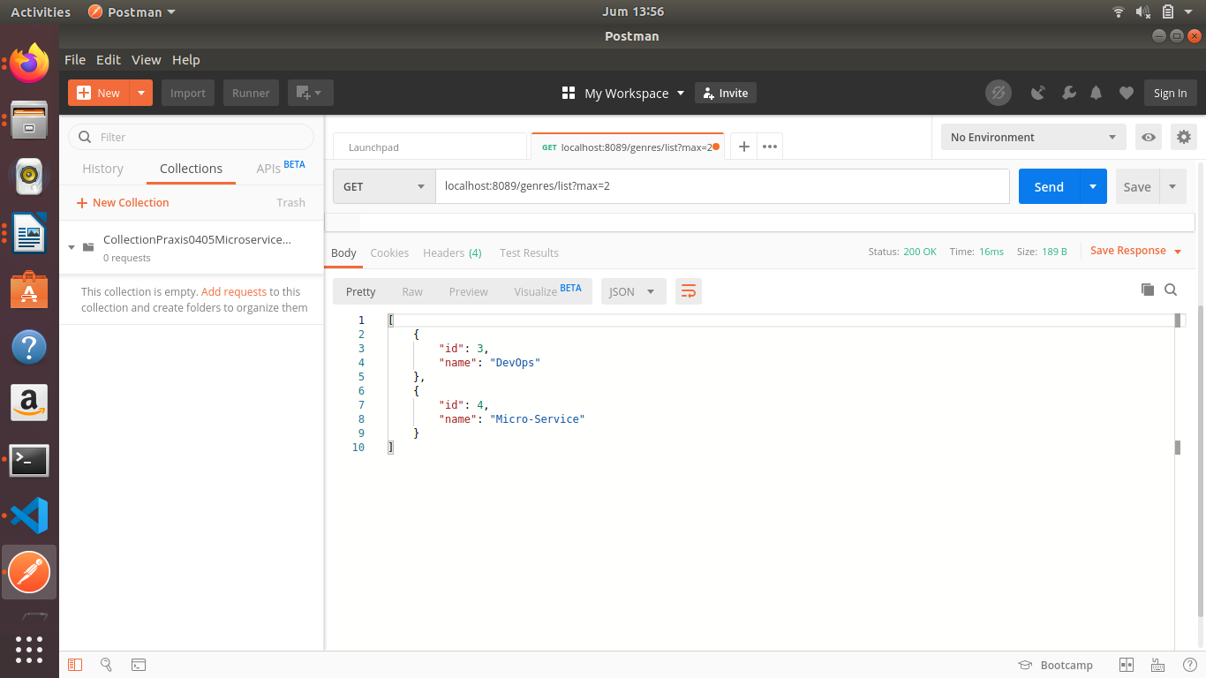

Menampilkan 2 buah record maximal, dan di order berdasarkan nama secara descending

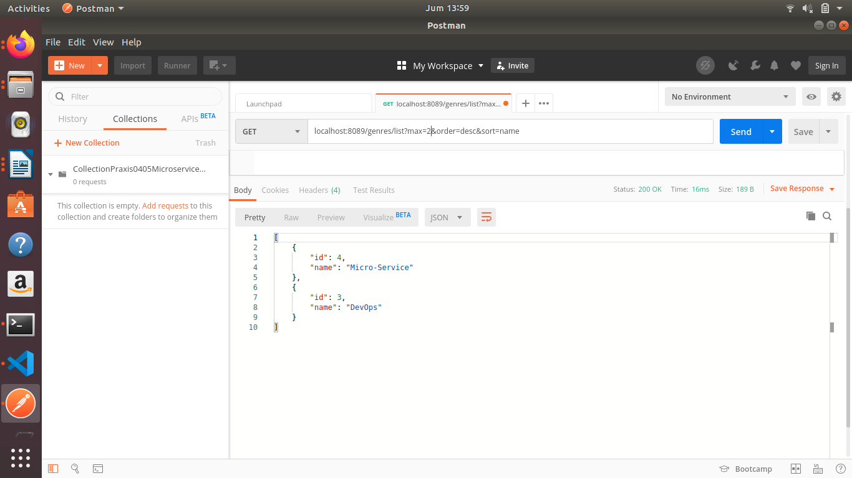

Menampilkan 2 record maximal, offset 10

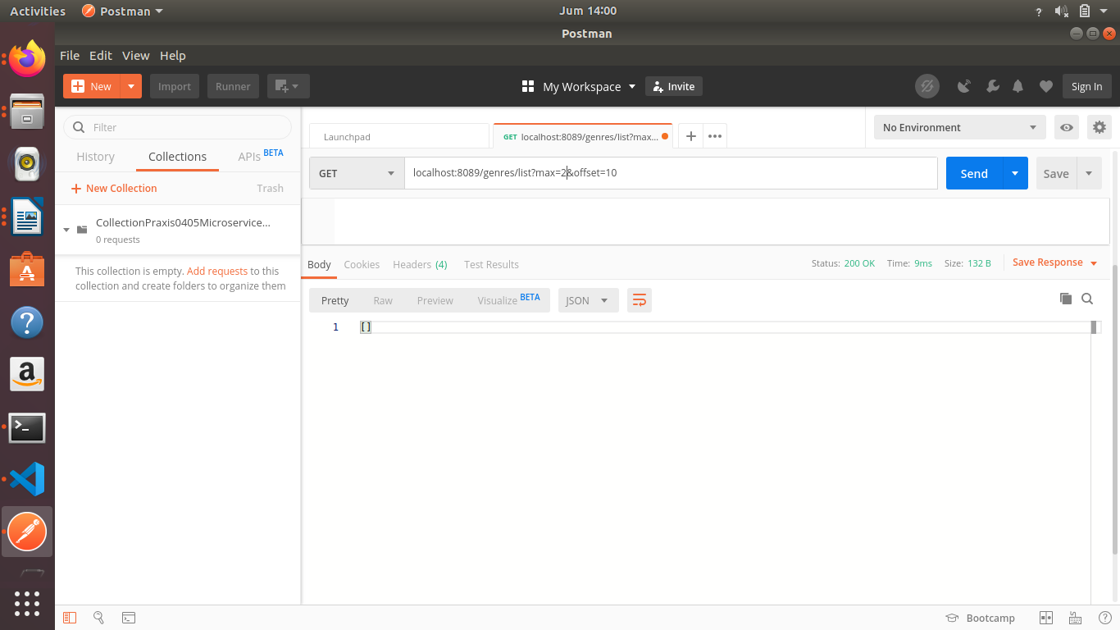

Menampilkan semua record sebelum di delete. Record ‘MicroService’ akan didelete

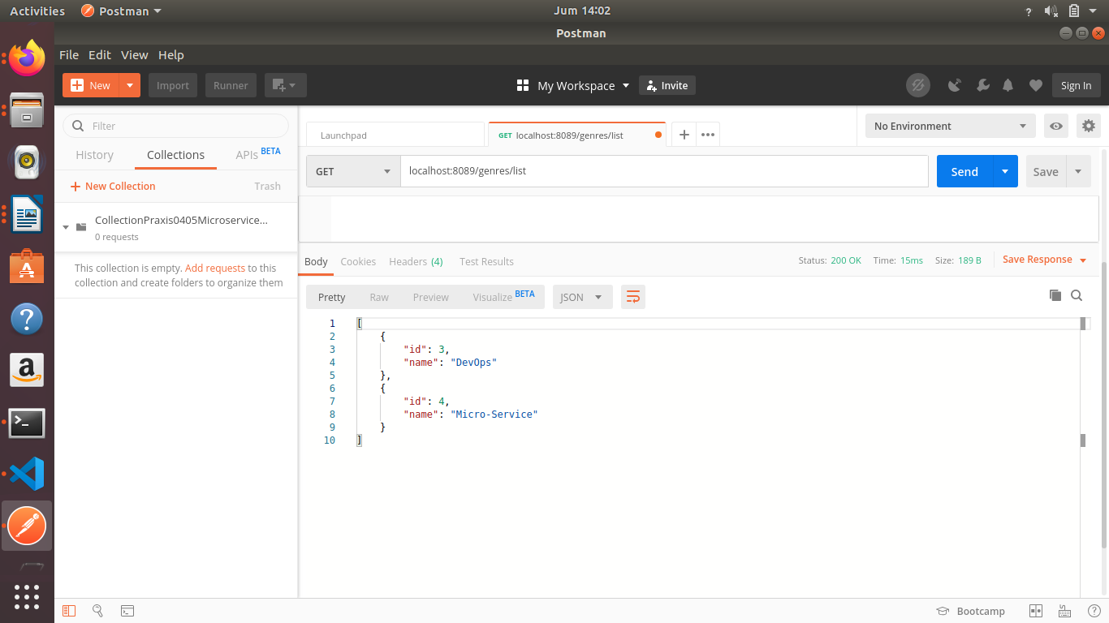

Mendelete bagian ‘MicroServce’

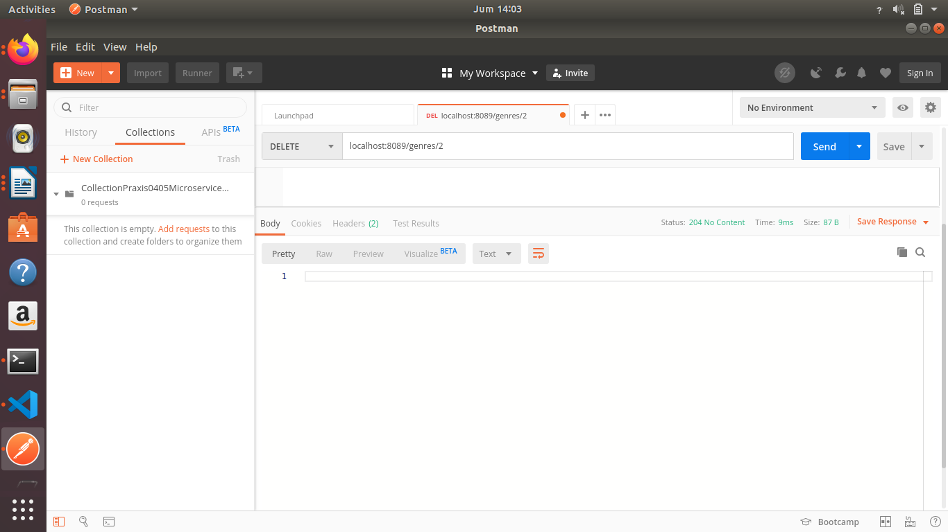

Menampilkan semua record hasil delete, maka record ‘MicroService’ akan tidak ada di record

